Contents

Introduction 3

Entering New Patient 3

Editing Patients Information 5

Handling Codes 6

Adding or Editing Codes 7

Price Level 8

Adding Fee for Price Level 8

Selecting Price while creating a encounter 9

Selecting Price per Procedure 10

Entering Smart fee sheet 10

Setting Up Preferences for the Fee Sheet 10

Set default Service facility 12

Set Default Billing Facility 12

Set Default Billing Provider 12

Fee Sheet Template 12

Enabling Supervising Provider 12

Enable Encounter Provider Selection 12

Encounter Provider Rule Settings 12

Default Expanded Sections in Fee Sheet 13

Co-pay Association with CPT 13

Exception for miscellaneous option HCFA box 32 14

How to use the fee sheet 14

Ready to be billed 15

Don’t Bill Insurance 15

Accept Assignment This controls 15

Import Template 15

CPT Codes and Diagnosis Codes 16

Diagnosis for Advanced CPT 16

HCPCS 16

Non-Billable to Insurance 17

Payment 17

Misc. Billing Options for HCFA-1500 17

Save Without Justify 18

Submit 18

Entering Charges 18

Entering Charges from Smart Fee Sheet 19

Entering Charges from Batch Charge entry 20

Entering Charges from Encounter 21

Claims Manager 21

List of statuses and how it works in ZH OpenEMR? 22

Uncoded 23

Partially Coded 23

Ready for QC 23

Ready to te Billed 24

Billed 24

Denied 24

Paid 25

Patient balance 25

Authorize Failed 25

Capitation 25

# Introduction

ZH OpenEMR’s Advanced Billing feature is focused on providing capabilities to manage and improve your revenue cycle management by decreasing staff time required to handle Billing through seamless entry, posting and A/R management. This document helps you understand how to use the Advanced Billing Module to achieve better outcomes

## Entering New Patient

To create a new patient, click on the ‘New Patient’ button in the top left corner as shown in the below screenshot. This will redirect to the “Search or Add Patient” screen also shown below.

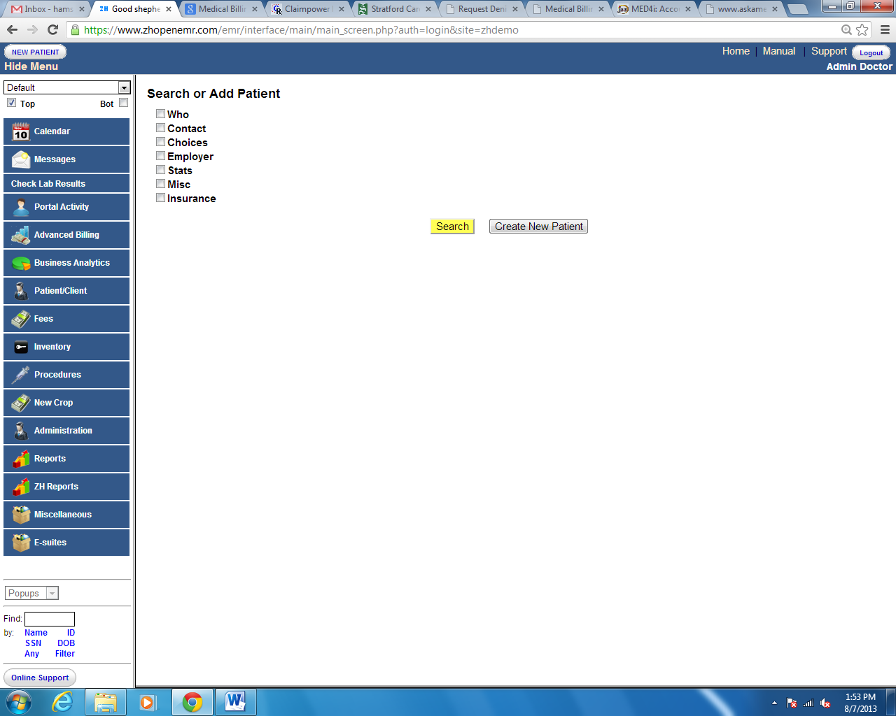

Check the square box to see the expanded view of the field and enter the demographics in the appropriate field as shown below,

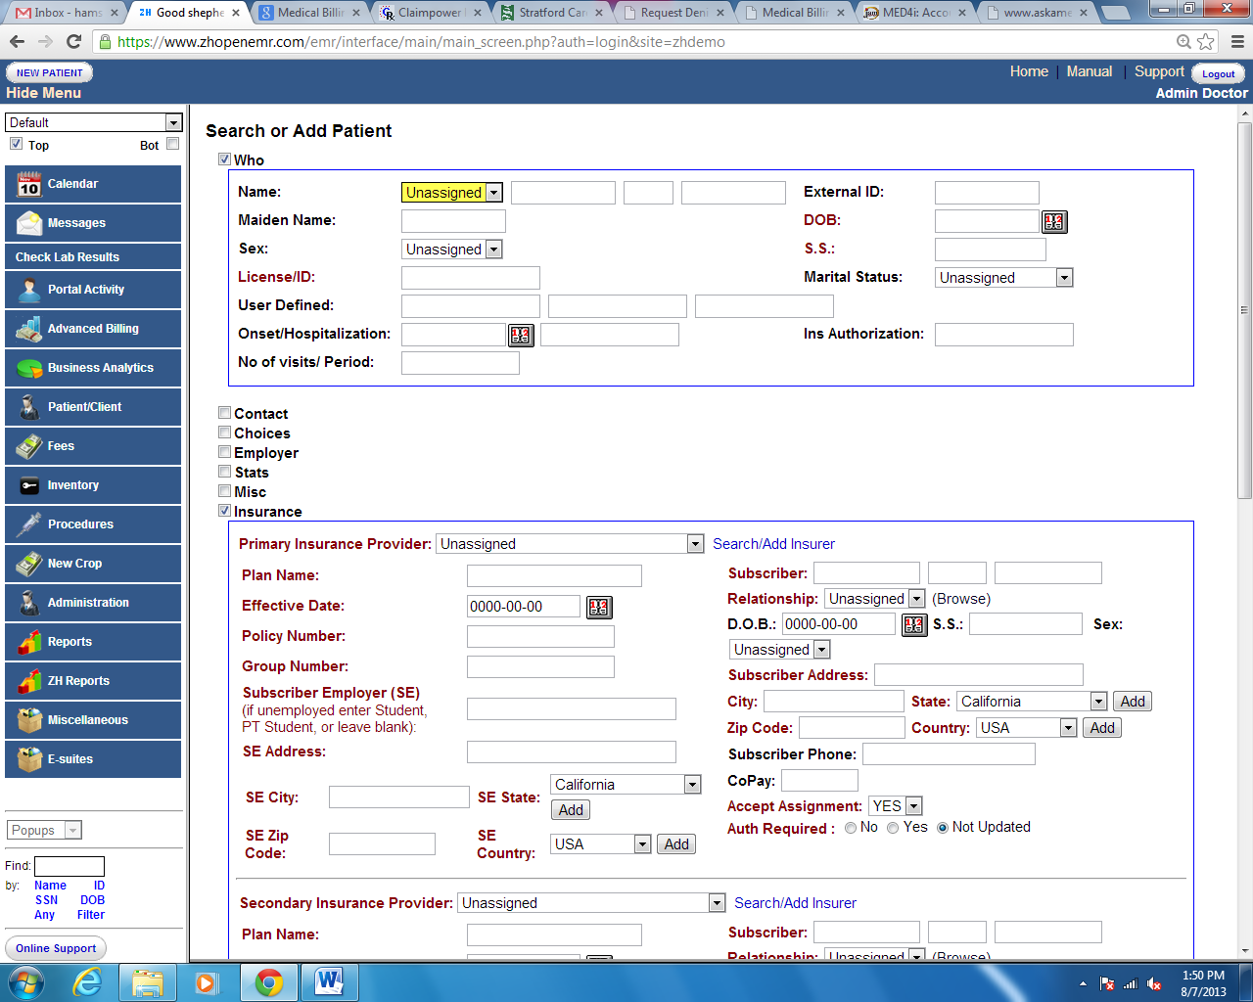

If a patient already exists in the system – it gives an error pop up as shown below,

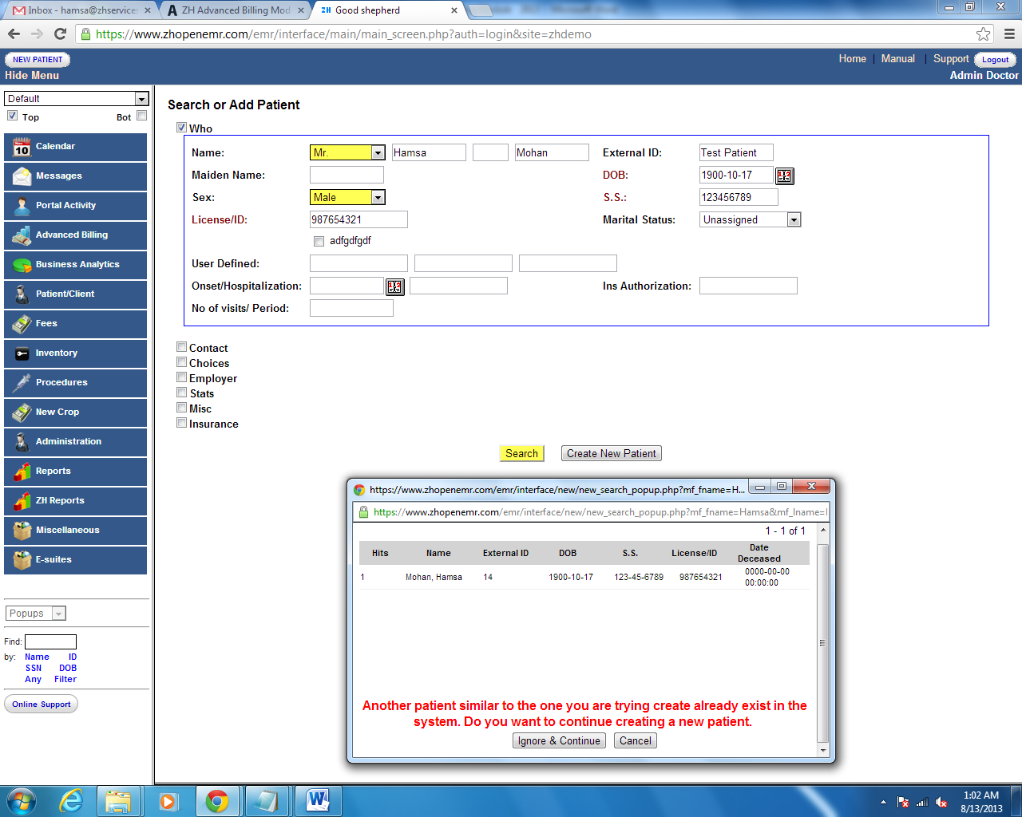

## 

## Editing Patients Information

To edit Patients details, click on the specific field (like Demo, Insurance, Notes, Patient reminders, Allergies, Clinical Reminders, etc.) as shown in the below screen shot.

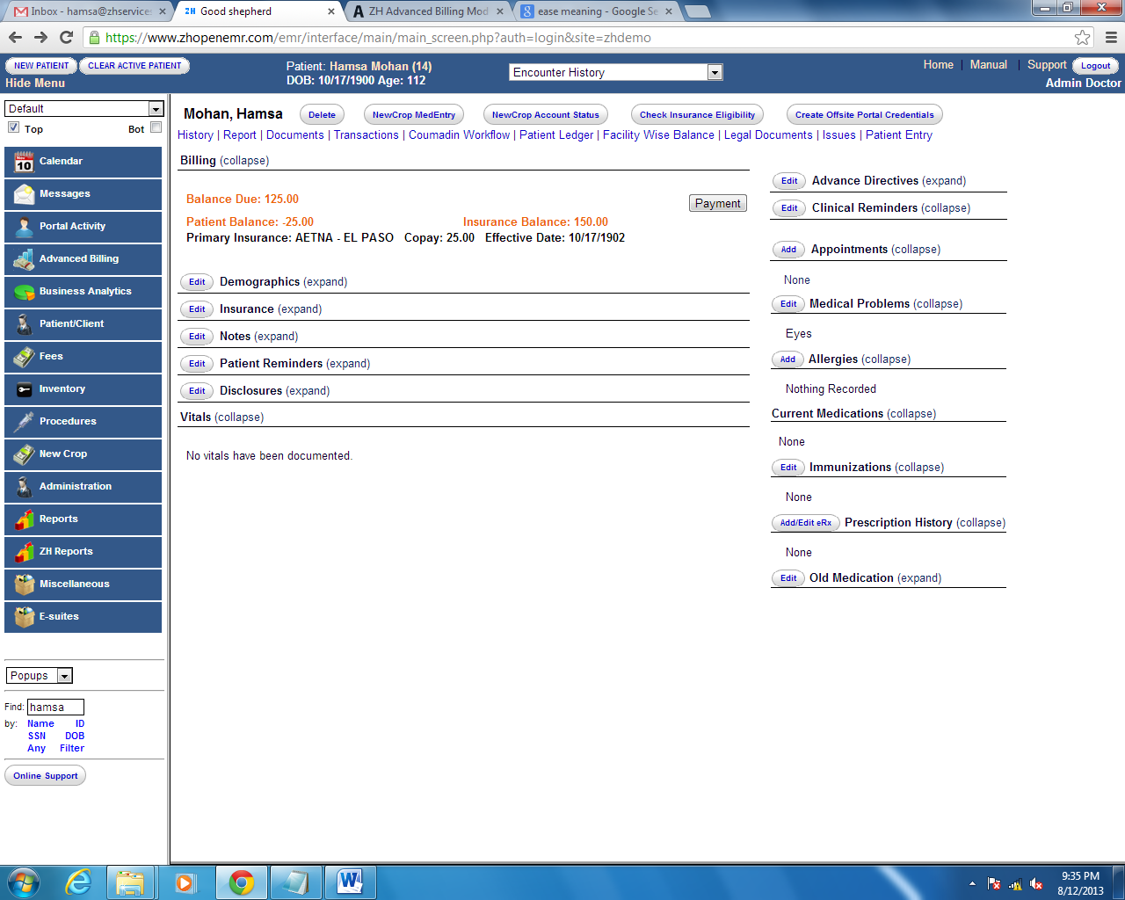

Edit buttons are highlighted above for each field to edit information pertaining to patient.

# 

# Handling Codes

In ZH OpenEMR user can add/update codes in the system from a single screen. It could be CPT, HCPCS, Diagnosis, Immunization code, or No-show, which can be added or updated in the system. Codes can also be listed as active or inactive upon update. ZH Open EMR has an additional notification for codes as reportable or non-reportable which makes it available for MU reporting.

Type of codes in the system is ICD9, CPT4, HCPCS, NOSHOW (For which practice doesn’t want to bill insurance), and CVX (Immunization code)

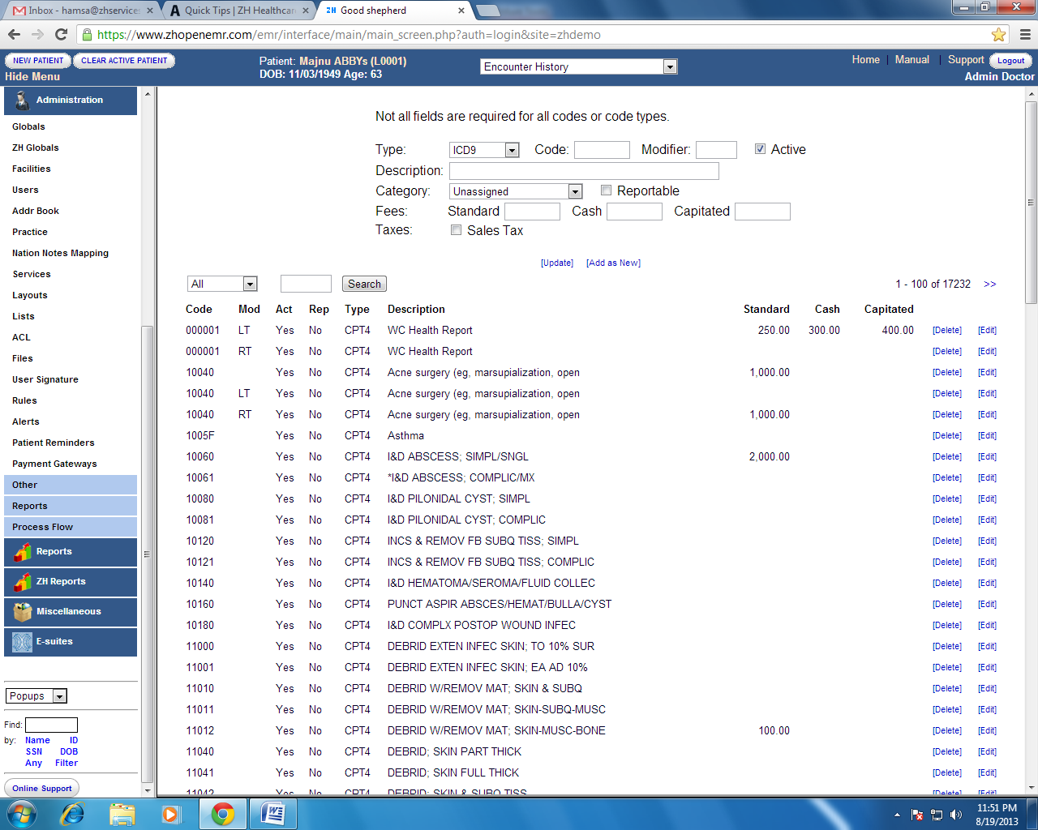

## Adding or Editing Codes

To add a new code enter required information in the field as shown in below screen, 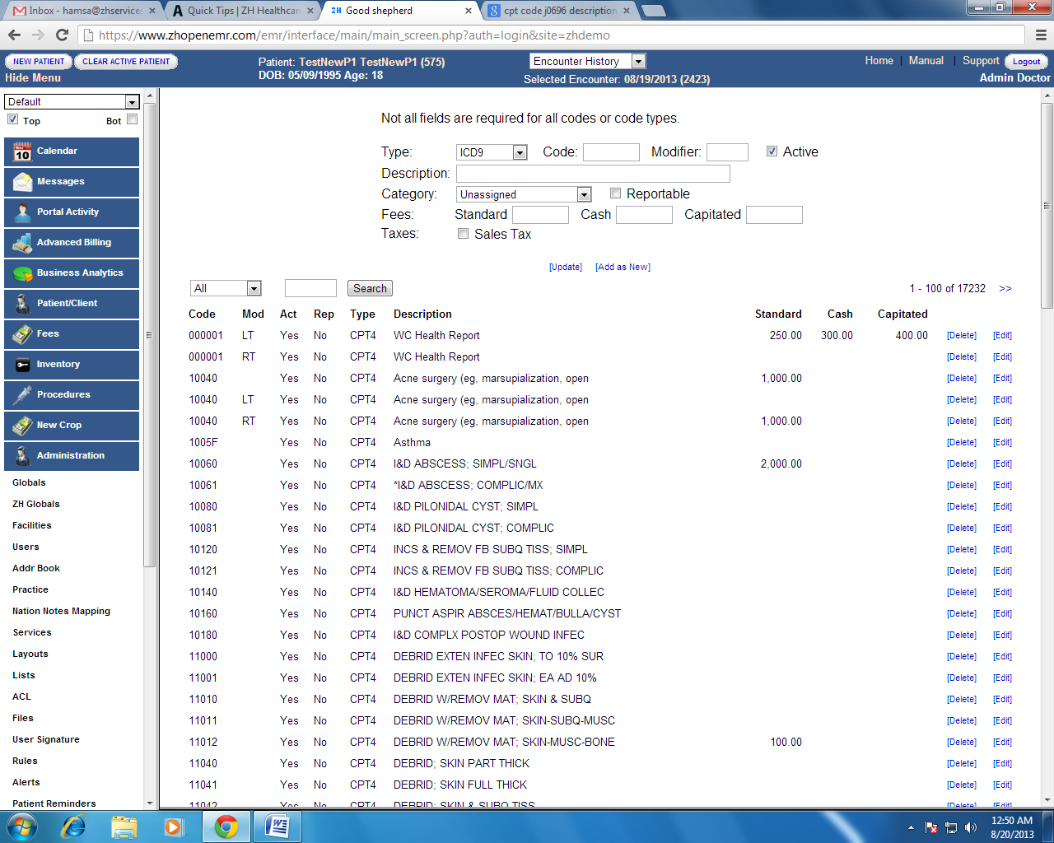

Follow the steps below to add a new code and to update existing code,

1. Select the type of code.
2. Enter a new code.
3. Enter the modifier if required
4. By default Active box will be checked
5. Enter the description for the code.
6. Select the category for the procedure.

Note: See the module “How to add visit category” (We have to use numbering to help user in finding the modules listed in the Quick tips in the website)

1. Check the box, if the procedure code is reportable for MU.

Update button shown in the above screen is to update information on the existing code.

Add as New button is to add a new code to the list.

## Price Level

ZH OpenEMR allows the Practices to define more than one price level per Cpt. The system also lets the user define how many levels of pricing needs to be in the system.

In order to add pricing levels click on Lists under the Administration Tab. This will bring the drop down menu of all the lists available in the system. Select the list titled Price Level as shown below.

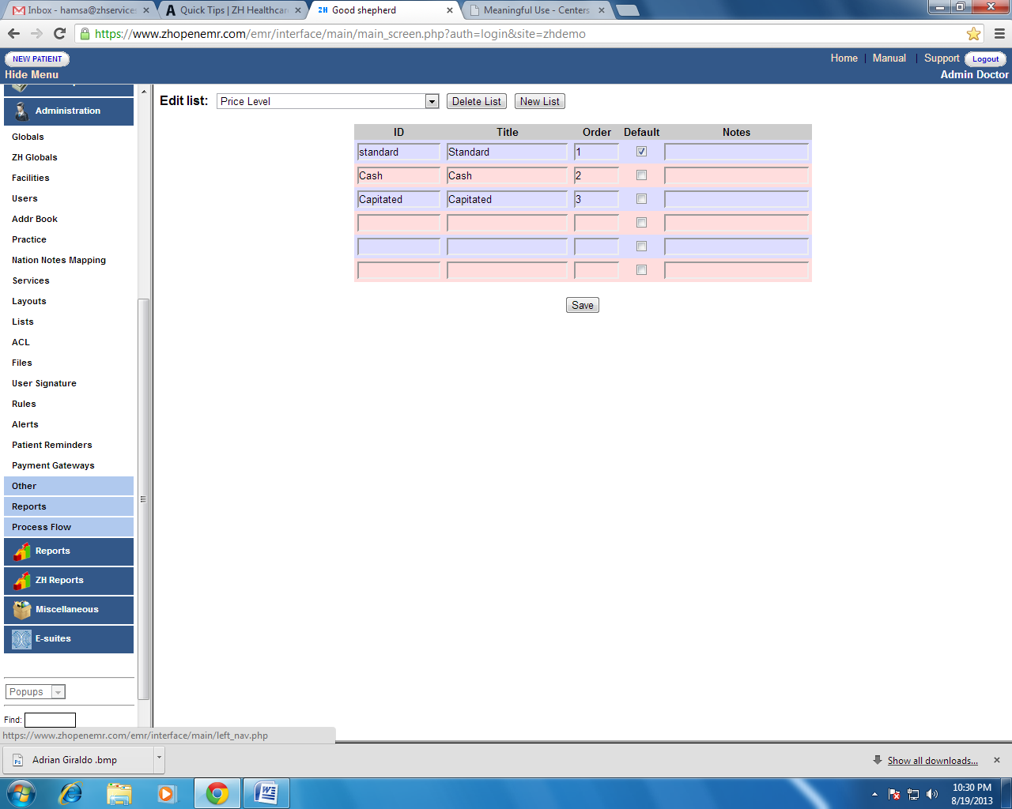

This list defines the levels of pricing available in the system. In the above example three pricing levels has been defined namely Standard, Cash and Capitated. The user can define as many levels as required and the order defines how they will appear in the screen where the fees are added.

The user can determine which price level should populate as default while creating an encounter by checking the box as shown in the above screen.

## Adding Fee for Price Level

User can add fees for the price level for both existing and for new codes. Practice can define the fee for Price level for each Procedure.

For eg., Medicare Standard Fee can be entered in the Standard Price level, Cash price level can be used to bill self pay patients or service which is not covered by Medicare can also be entered in this price level, Procedures covered by capitation can be entered in this field.

Please see the below screen for its representation.

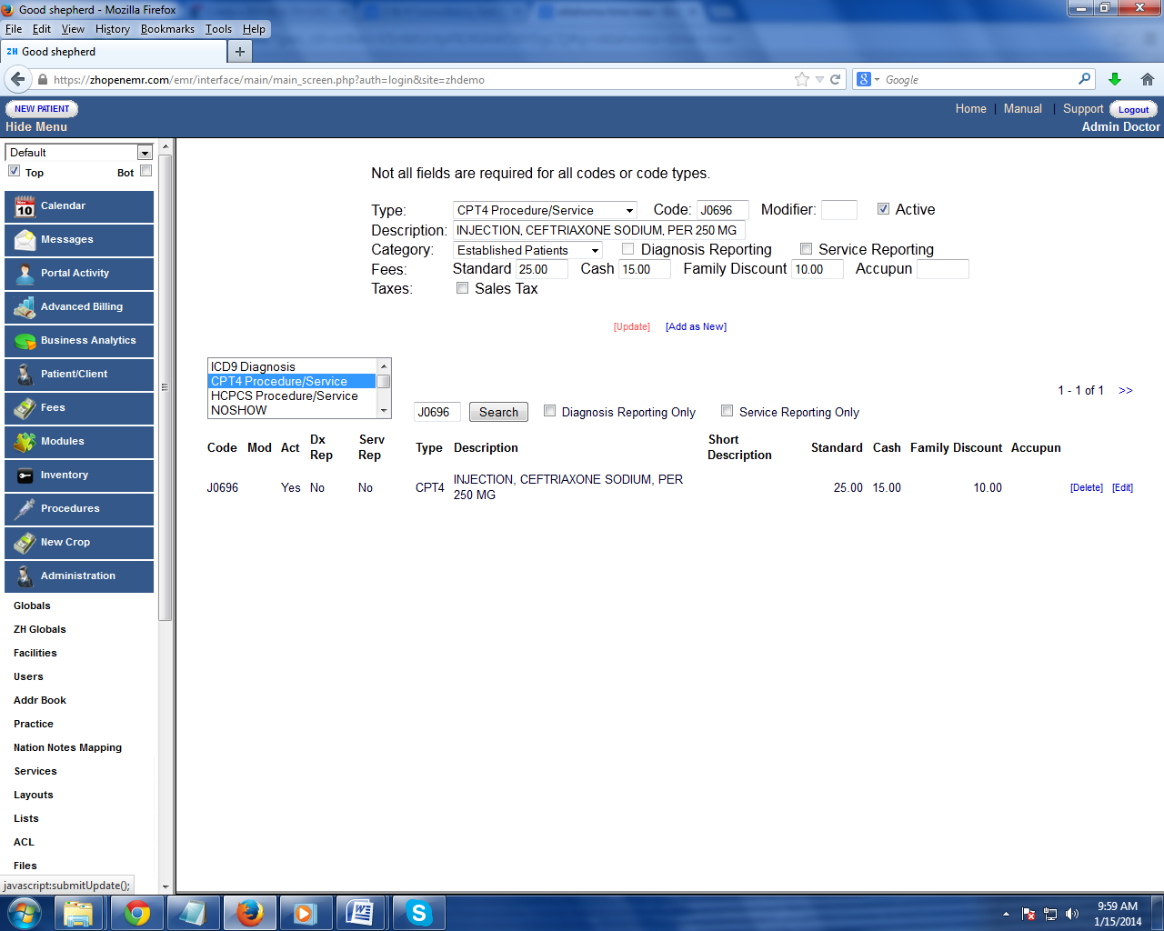

## Selecting Price while creating a encounter

Price Level can be chosen from a dropdown box while creating an encounter as shown below. The default price level will be according to the default value set in the list Price Level – Please see above section for more details. Upon the selection of the price level, system will pick up the fee values for the procedure.

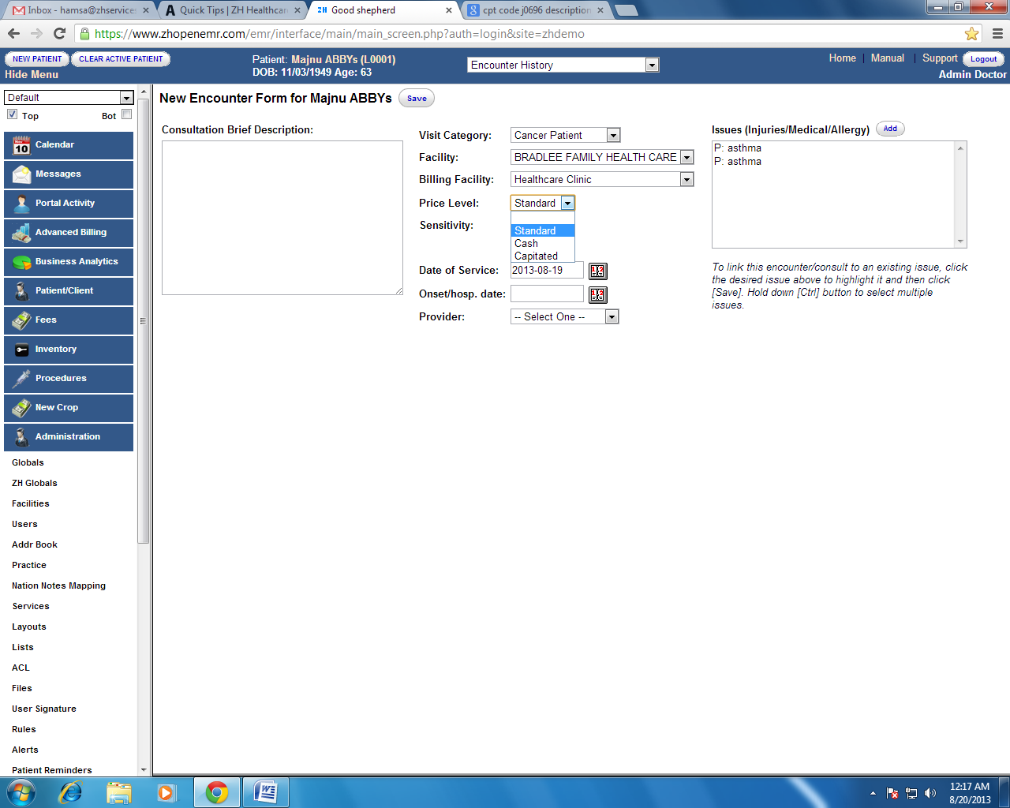

Selecting the Price Level from Fee sheet

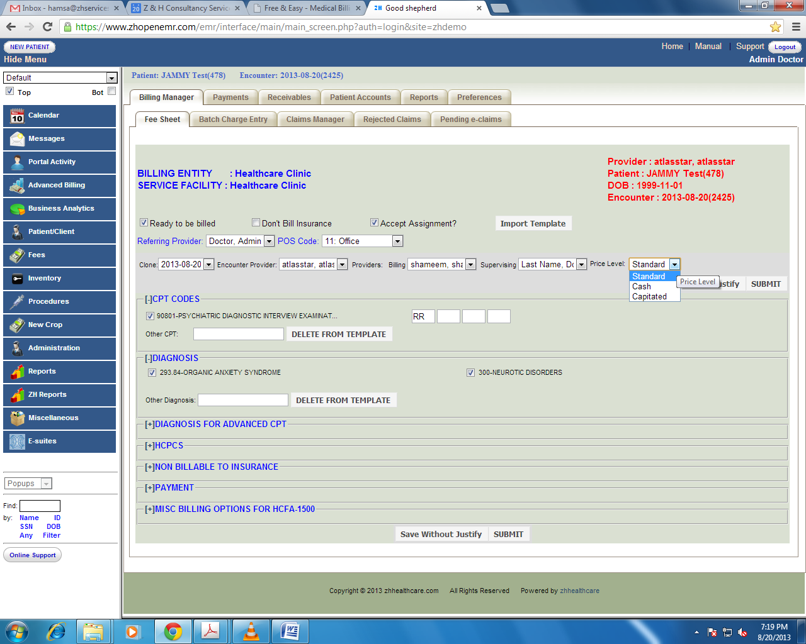

## Selecting Price per Procedure

Price level can also be chosen per procedure while code mapping from fee sheet as shown below.

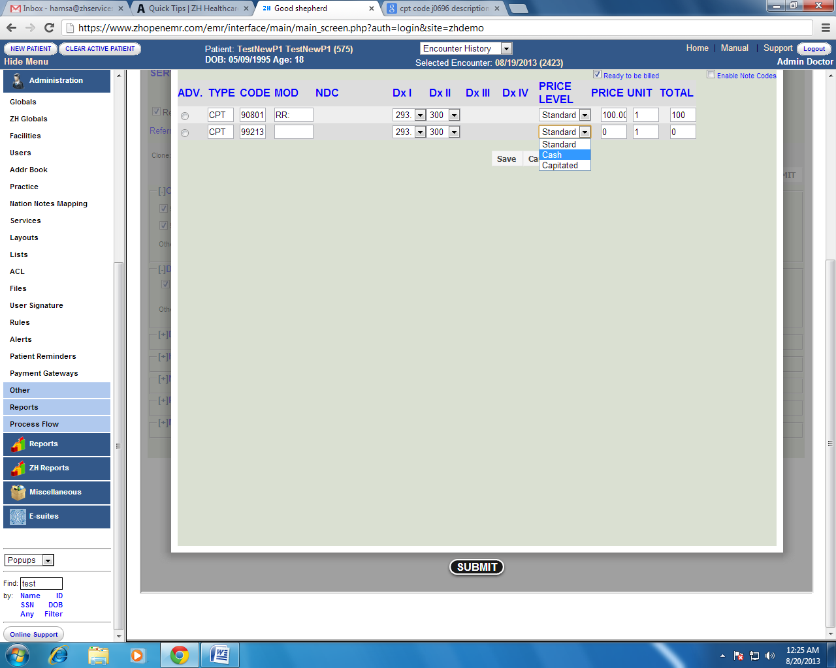

# Entering Smart fee sheet

This section helps the user, how to use the Smart Fee Sheet. It explains the various settings and how the fee sheet can be accessed from multiple locations.

# Setting Up Preferences for the Fee Sheet

Before starting to use the Fee Sheet the user needs to setup the preferences. The below screen shows, how to go to the preferences of the fee sheet to do the master set-up.

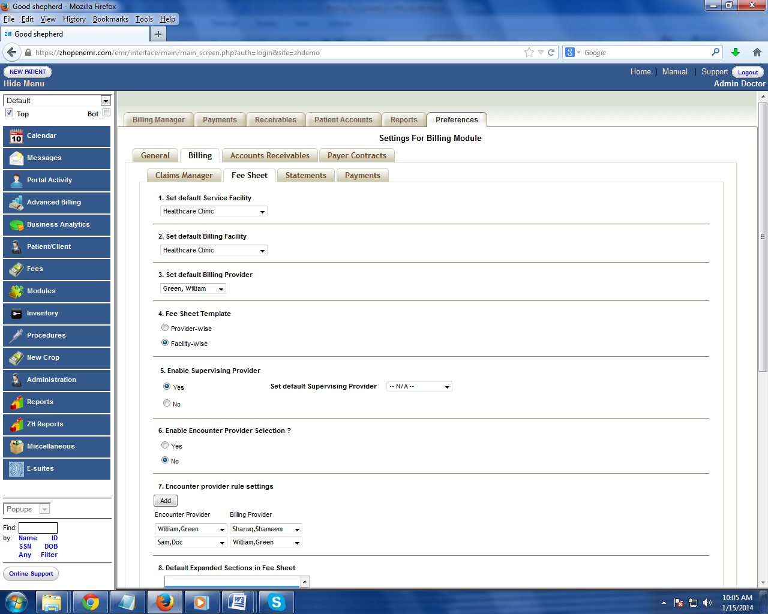

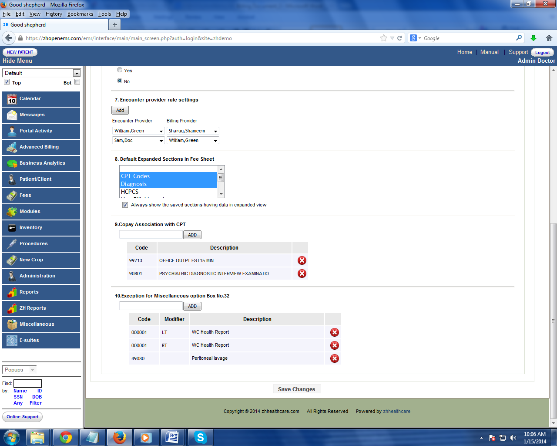

Please see the below explanation for each field in setting up the fee sheet preference:

### Set default Service facility

Select the service facility that needs to be defaulted in the Fee Sheet from the dropdown list. While entering individual fee sheets the service facility can be changed per visit. (Reflects in HCFA form box 32)

### Set Default Billing Facility

Select the Billing facility that needs to be defaulted in the Fee Sheet from the dropdown list. While entering individual fee sheets the Billing Facility can be changed per visit(Reflects in HCFA form box 33)

### Set Default Billing Provider

Choose the billing provider that the fee sheet needs to default in this section. (Reflects in HCFA form box 33)

### Fee Sheet Template

This option has an ability to display Practice wise or Provider wise fee sheet template. The procedures and diagnosis codes been added in the template based on the usage of an individual provider or facility. For example, if provider billing a procedure 11712 which is not listed in the template, will be automatically included in the template for individual provider or for the facility provider after using it for the first time.

Provider wise or Facility wise template will be shown while entering the charges based on the set-up made in fee sheet.

### 

### Enabling Supervising Provider

By enabling the supervising provider in the fee sheet preference, it shows a list of provider to select as supervising provider and it is set default as a supervising provider for the smart fee sheet.( Reflects in HCFA form 31 )

### Enable Encounter Provider Selection

If a facility has to bill claims for some providers under another provider in the same clinic – this feature needs to be enabled. This allows the system to create encounters under the rendering provider but create claims linked to another provider who will be called the Billing provider.

### Encounter Provider Rule Settings

Once the above feature is activated this setting allows to link rendering providers to the billing providers automatically selected in the Fee Sheet. For Example: Select Encounter/Rendering provider and Billing Provider from the dropdown list shown below, It will be set as rule as whenever we select Encounter Provider as “Sam, Doc”, then by default the billing provider will be “William, Green” as shown below.

The Add button shown below is to add rule for multiple provider.

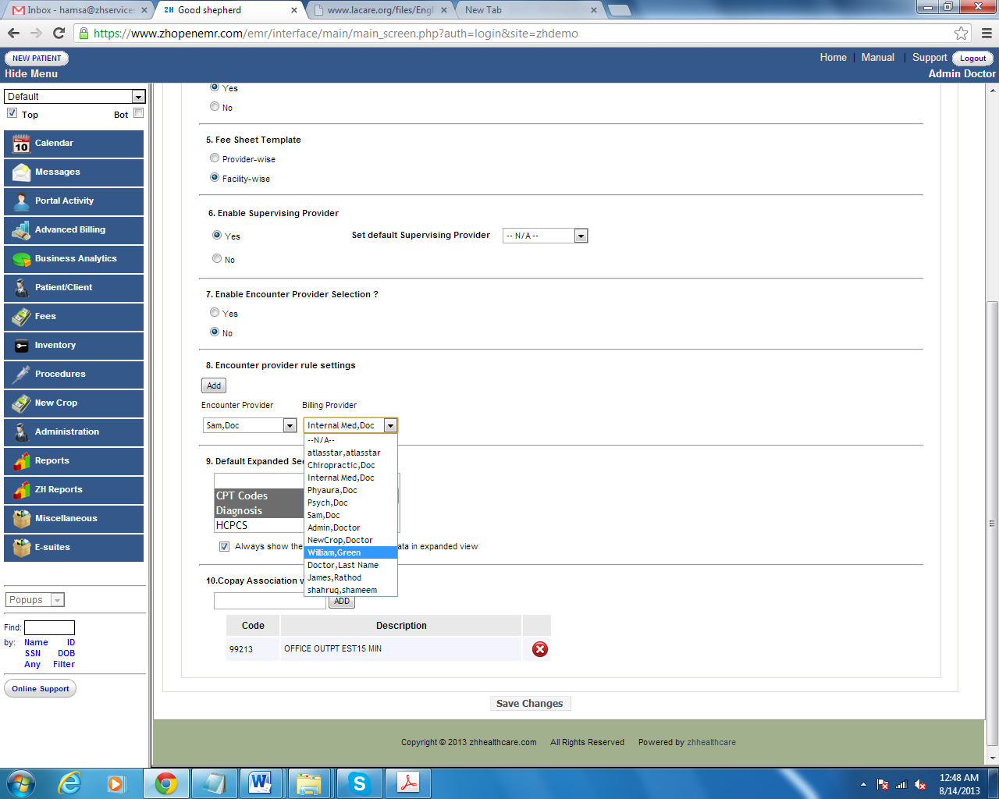

### Default Expanded Sections in Fee Sheet

Select the sections which need to be shown in expanded view while entering the charges.

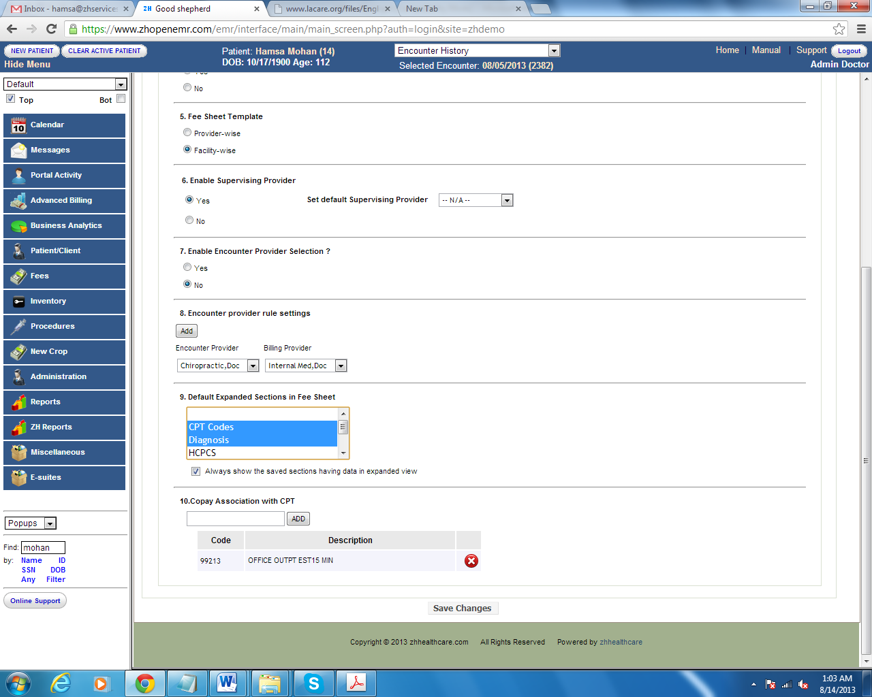

Press CTRL to select more than one section to be shown in expanded view.

Below is the representation of expanded view based on selected section.

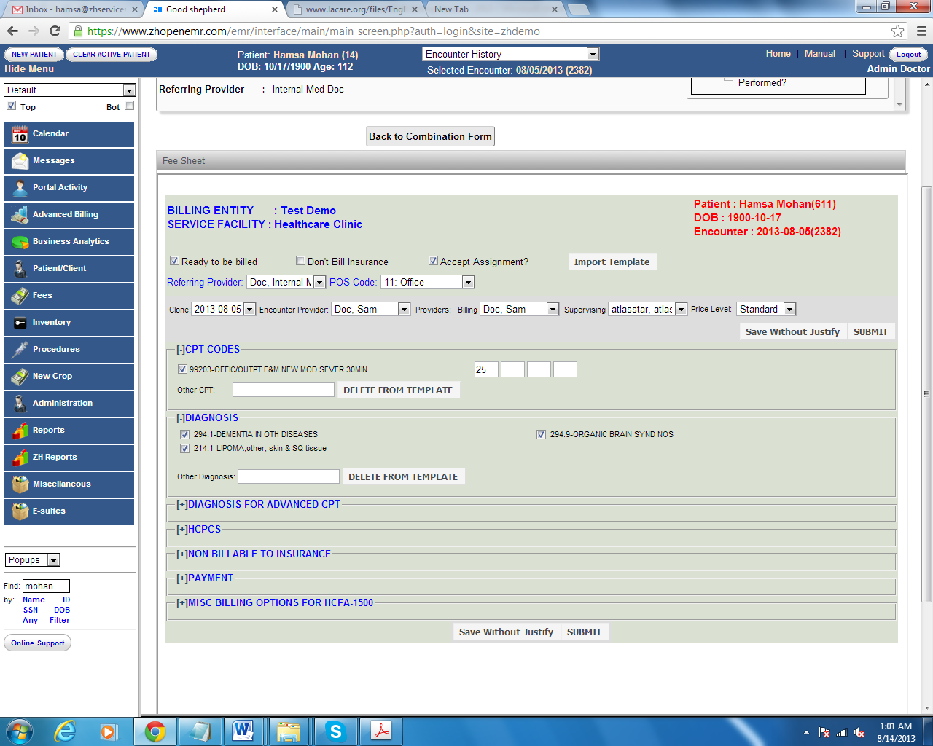

### Co-pay Association with CPT

Usually Co-pays are posted prior to the CPT being entered. By choosing the CPTs in this section the system will automatically link the Co-pays to the selected CPTs. If none of the CPTs listed in the claim associated with the co-pay, System automatically links co-pay with the primary procedure for the particular encounter.

### Exception for miscellaneous option HCFA box 32

Claims will carry patient’s address in HCFA box 32, when place of service is 12. Users can restrict the system to carry patients address instead of Service Facility address by adding home care procedures and orders collected by patients in office.

Ex: Podiatrist supplies diabetic shoes (CPT-L3000), which is collected by patient in the office, though the place of service is 12. Users can set the preference by adding procedures to make the system carry service facility address.

# How to use the fee sheet

Below is a representation of the Fee Sheet which is explained in detail in this section.



Ready to be billed Users with any of the following access like Auditor, Accounting, Physician and administrator have the access to justify the procedure code and diagnosis which moves any of the prime status to Ready to be billed for billing.

Ex: After physician completes his notes, encounter will be flagged either with status “Partially Coded” or with “Uncoded” in the claims manager. Then the user with the above access can justify the codes which move it to “Ready to be Billed” status.

Don’t Bill Insurance Checking this box makes the claims directly become patient responsibility and will not made available to be filed to the insurance even if there is an active insurance in the system for that date of service.

Accept Assignment This controls the entry to be made in Box 13 in the HCFA form on which the assignment of benefits is applied. This check box is defaulted according to the entry made while creating the billing facility in the system

Import Template Practice should determine whether they require a facility wise template or practice wise template for their regular work flow.

Facility Wise Template: CPTs and Diagnosis made as template will be shown to all the providers for the service.

Provider Wise Template : CPTs and Diagnosis made as template will be shown to the particular provider.

Once they set up this in the advanced billing preference. User can create CPT or Diagnosis template by using the given field in CPT and Diagnosis section. The below screen shot shows where to populate the CPT and the arrow mark shows whether the CPT is just for the particular encounter or to the template.

CPT Codes and Diagnosis Codes Cpt and Diagnosis codes can be populated from the given field in the section as shown below,

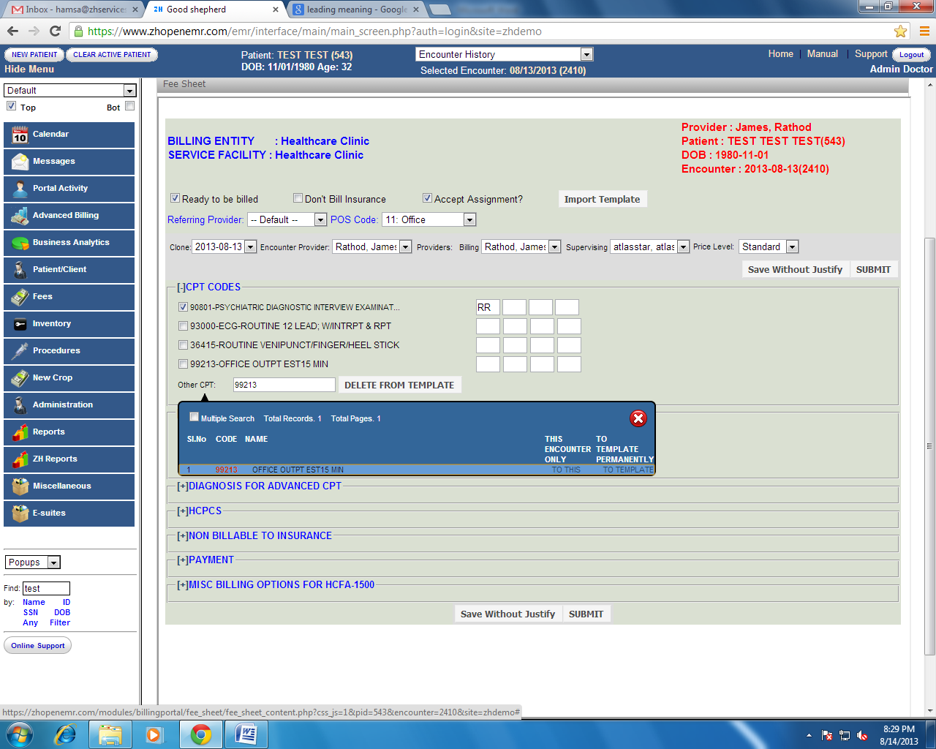

Click on the (+) button placed left beside the field to see the expanded view and to enter required information in the fee sheet.

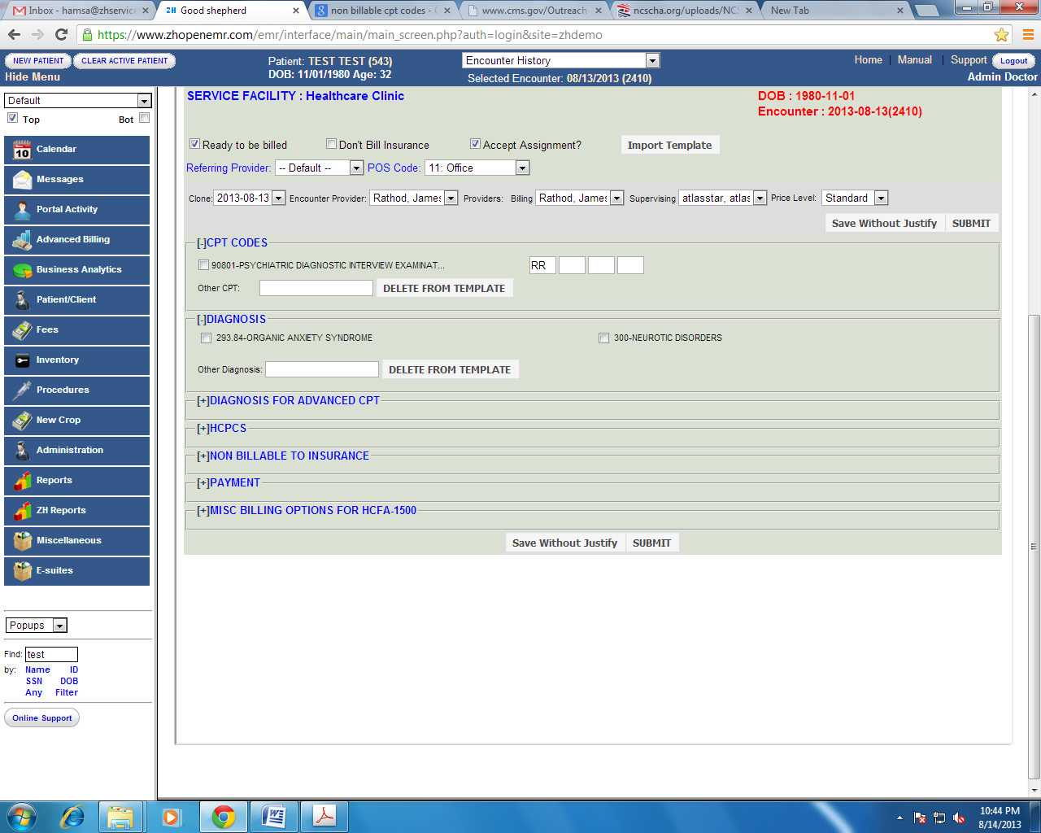

## 

## Diagnosis for Advanced CPT

Not clear

HCPCS Injection codes and Supply codes will be populated in this HCPCS field. (Ex: J0696, A5500, S2083)

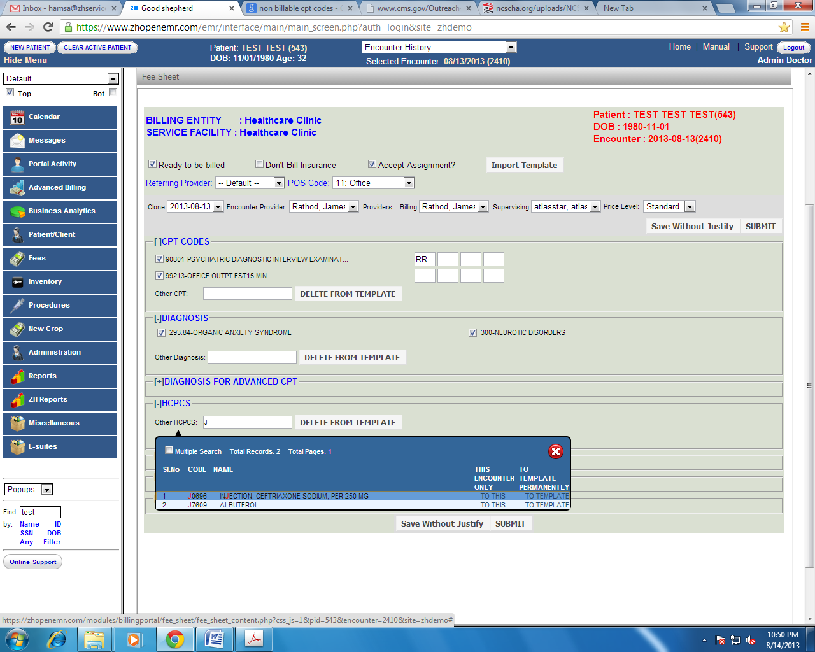

Non-Billable to Insurance

No show or service codes for which practice does not want to bill insurance. See Module “How to handle codes in system” to know how to make a procedure listed under non-billable to insurance.

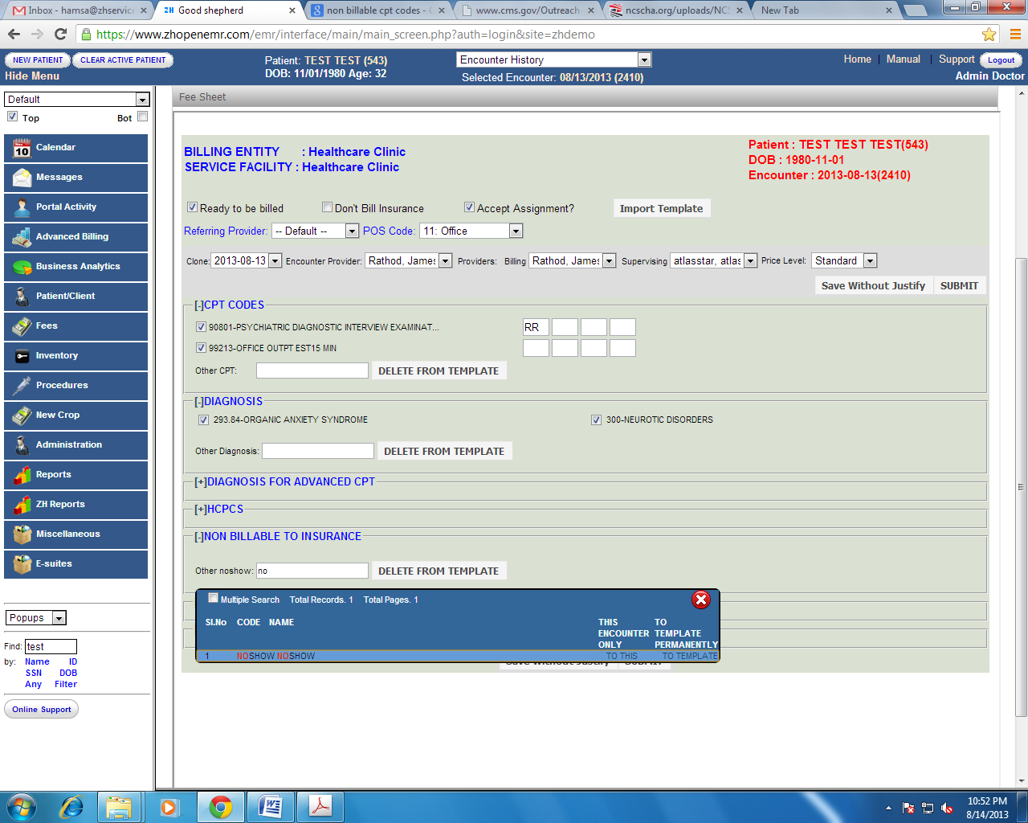

Payment User can enter Co-pay or pre-payment made at the time of service related to the service date with the payment method and check detail.

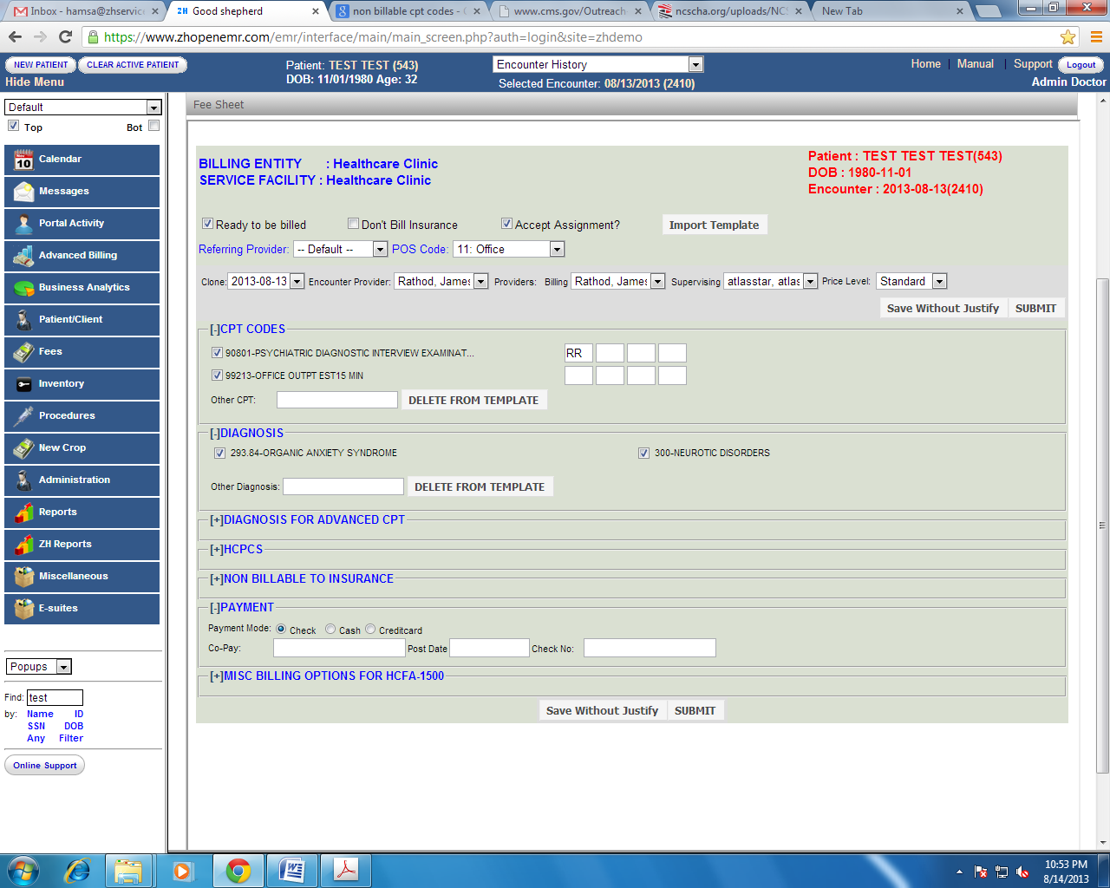

Misc. Billing Options for HCFA-1500 Use the miscellaneous tab to enter information pertaining to Workers compensation, Auto accident, Inpatient hospitalization date, Prior authorization. This allows the system to reflect entered information in the appropriate HCFA box.

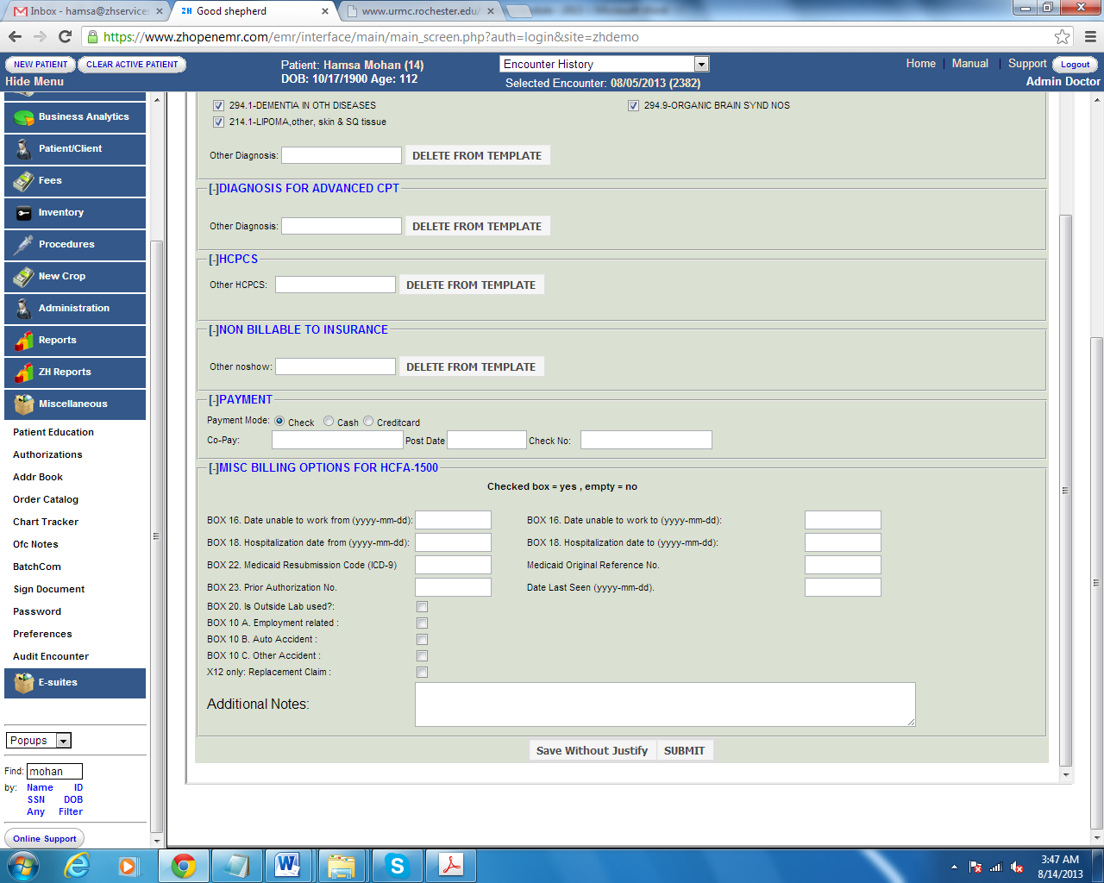

Additional Notes field is for local use, Used as a “remarks” field to indicate information helpful for claims processing, e.g. Corrected claim notification, injury/accident – how, where, and when injury/accident happened.

Save Without Justify This action button allows the biller to save the encounter without justifying the procedure codes with the diagnosis codes. This action flags the claims as either “partially coded” or “un coded”.

Submit This action allows the biller to justify the codes and to save the encounter.

# 

# Entering Charges

ZH OpenEMR’s Advanced Billing has multiple ways to enter fee sheet from Billing Manager. Charges can be entered either from Smart Fee sheet or from Batch Charge Entry.

Please see the below screen shot for its representation,

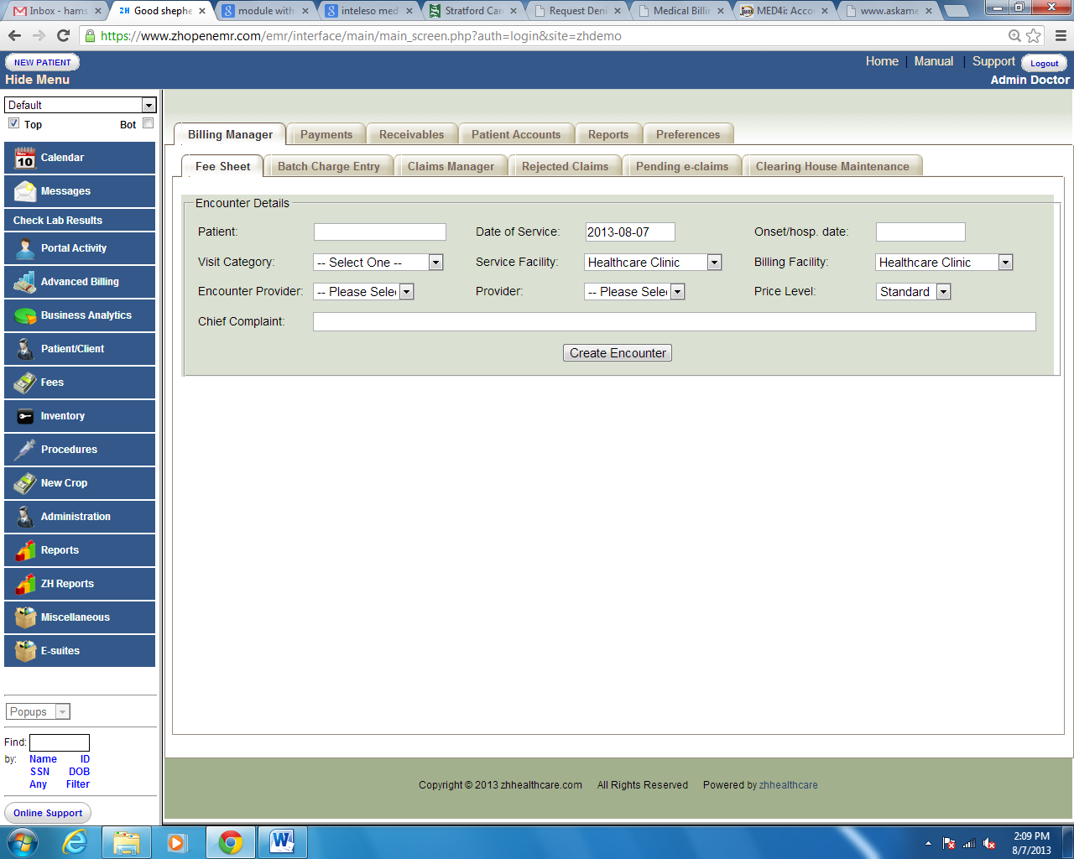

## Entering Charges from Smart Fee Sheet

When working with paper super bills user would need to create the encounter and then fill the fee sheet. To do this single encounter user can use the Fee Sheet button on the Advanced Billing under Billing Manager.

Enter the required information to create the encounter in the fields shown above. Once done click on Create Encounter button shown above- This will create the encounter for that date of service for the patient and being up the Fee Sheet as shown below. Enter the relavant information like CPT, Diagnosis etc to complete the Fee Sheet and hit Save.

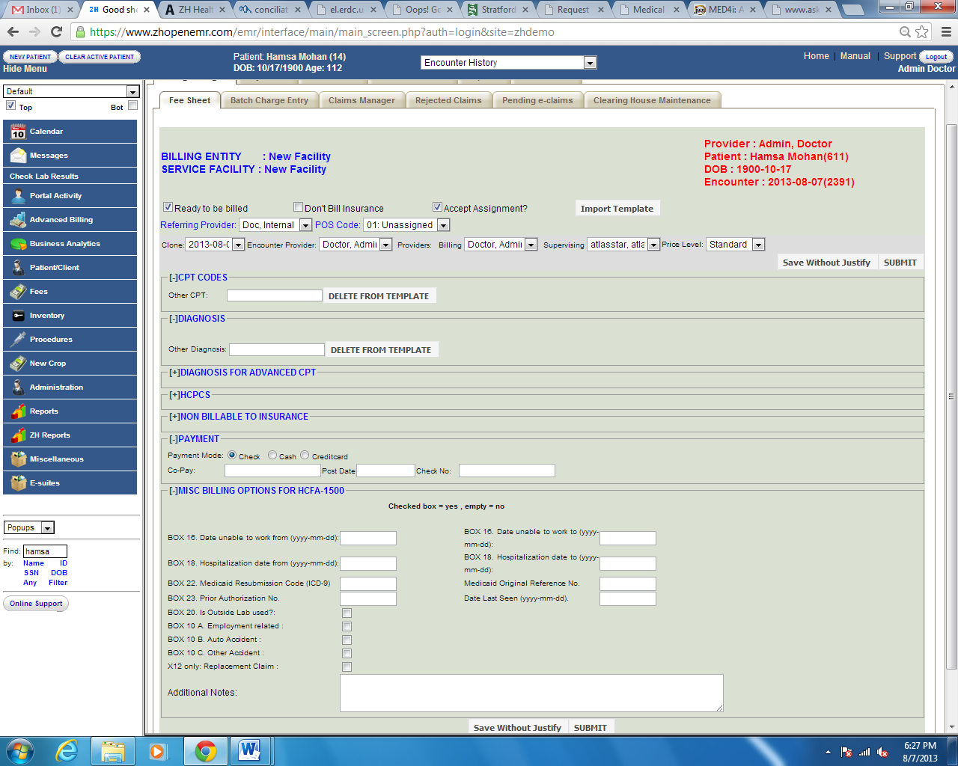

See Module “How to use fee sheet” to know how to fill up the fee sheet.

Once all the required field for the encounter/claim are entered. It can be either submitted to insurance by clicking on Submit button or to save the claim without submission- click on the Save Without Justify button. Save without Justification feature let the claim to be shown under Ready to be Billed status.

## Entering Charges from Batch Charge entry

The simplest way of entering multiple charges in one screen will be detailed in the next screen shot.

ZH OpenEMR created a simplest way of entering multiple charges in one screen. To enter multiple charges, Click on Batch Charge Entry button from Billing Manager, Where it has an option to enter 4 charges in one screen.

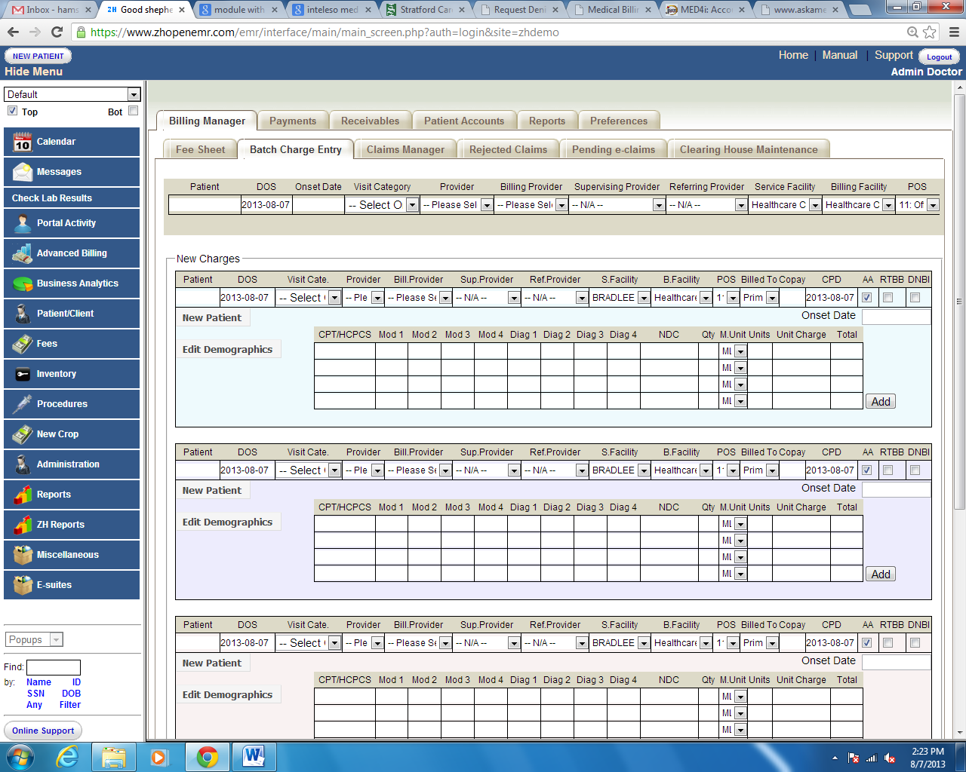

It shows 4 rows to enter services procedures. To add more rows, click on **Add** button shown below,

Once you enter all the required field for the encounter/claim. It will be queued for QC.

## Entering Charges from Encounter

Charges can be entered from the encounter screen or in the other words physician note taking screen. There is a fee sheet button in the encounter screen below the visit detail. Providers can select the CPT and Diagnosis from the fee sheet template. Below screen shows the encounter screen and how to select the fee sheet from the encounter screen.

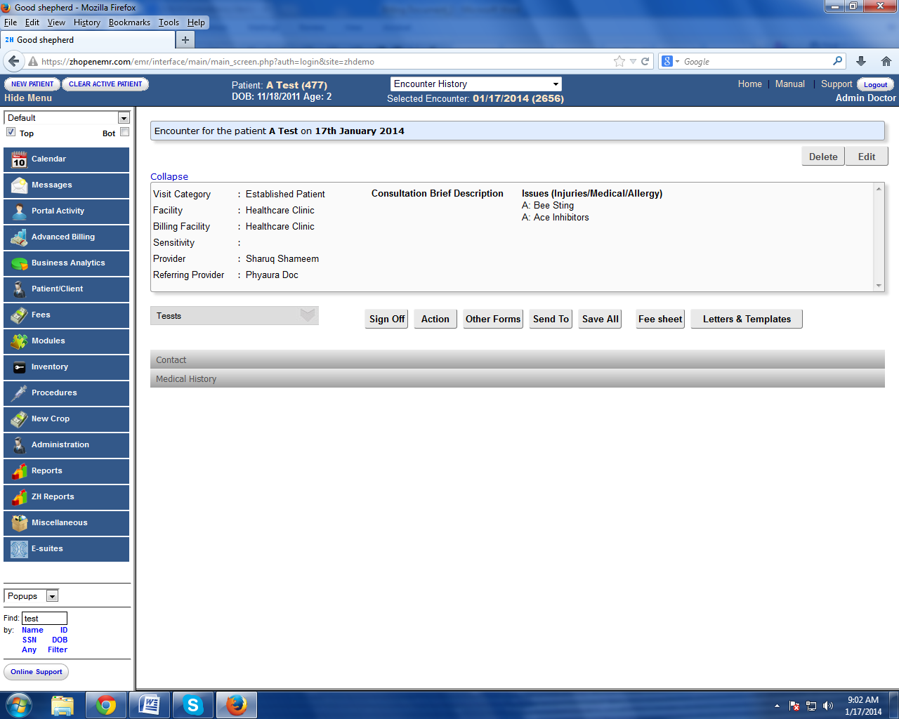

# Claims Manager

ZH OpenEMR’s Advanced Billing (ABM) optimizes the system to show-up all the claims. This enables to view all the action codes in a single screen.

Charges entered in the system and flagged to bill will be visible in the below screen

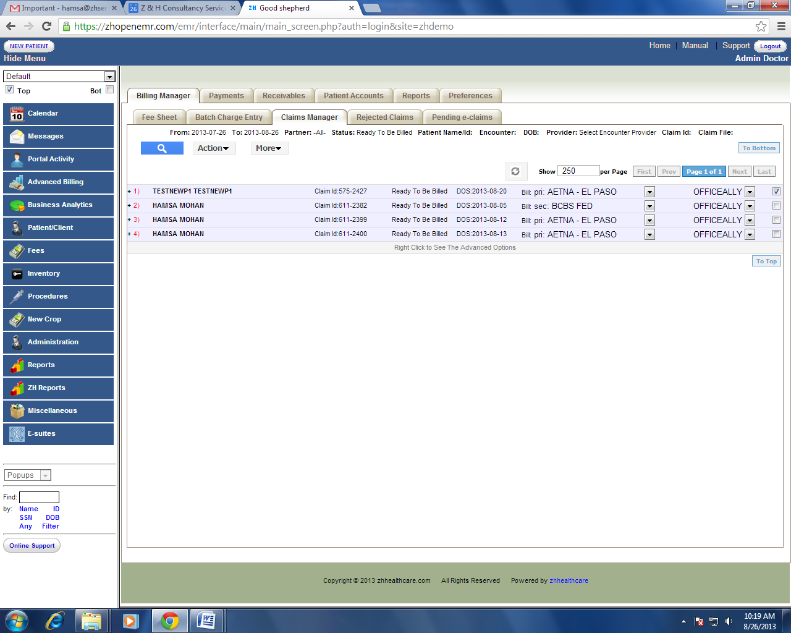

Search option helps the user to cutomize their search as needed.

List of status codes which are shown in the below search option screen, helps the user to generate the claims that required action.

List of partners

Clearing house is being integrated with the system for the practice or clinic will be listed in the drop down box. User can select as per their requirement of the claims from different clearing house as per the need. This also helps the user to identify from which clearing house the claims was sent and work on those claims.

Below is the representation screen to search claims associated with partners for the practice.

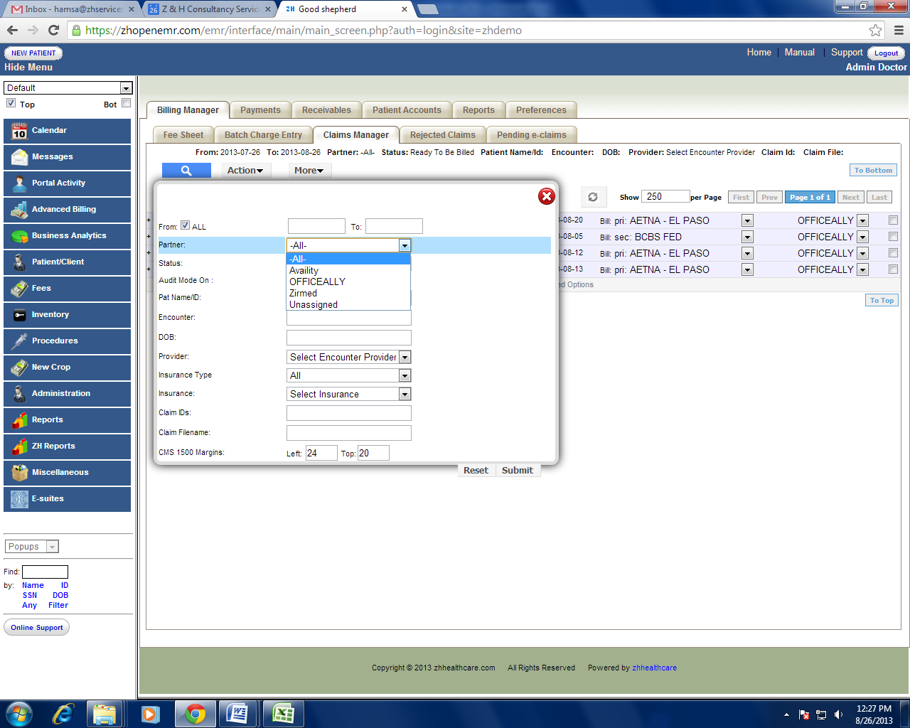

## List of statuses and how it works in ZH OpenEMR?

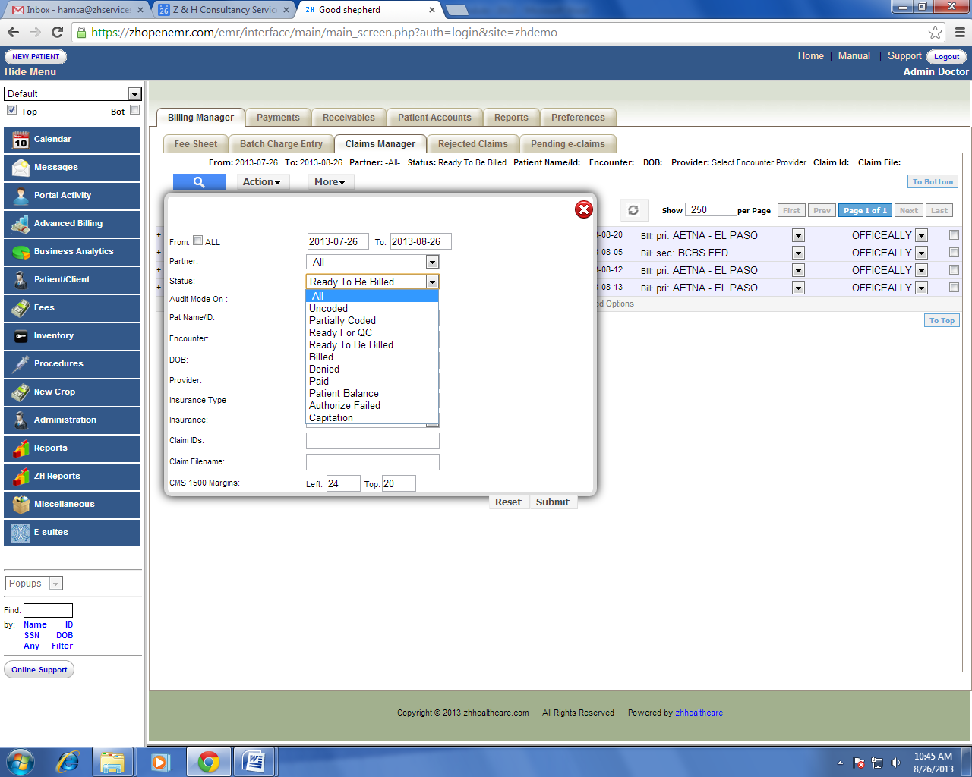

Status codes: This code enables to track claims with status codes.

See codes below and the explanations.

Uncoded Claims which do not have complete information like procedure code, diagnosis code missing or not mapped can be viewed and coded from the claims manager screen.

Partially Coded Claims which are saved with out justification during charge entry process can be viewed and also update the codes using this status. (See module section) () to know more about Save without Justify option.

Ready for QC Claims which are entered in the system will be queued as Ready for QC status. This search status helps the user to search and audit the claims to authorize for submission (queued to Ready to be Billed status) or user can make it authorize failed for further correction.

When quality check person search for claims using the Ready for QC status, It is required to check the

“Audit mode on” box right down. See below.

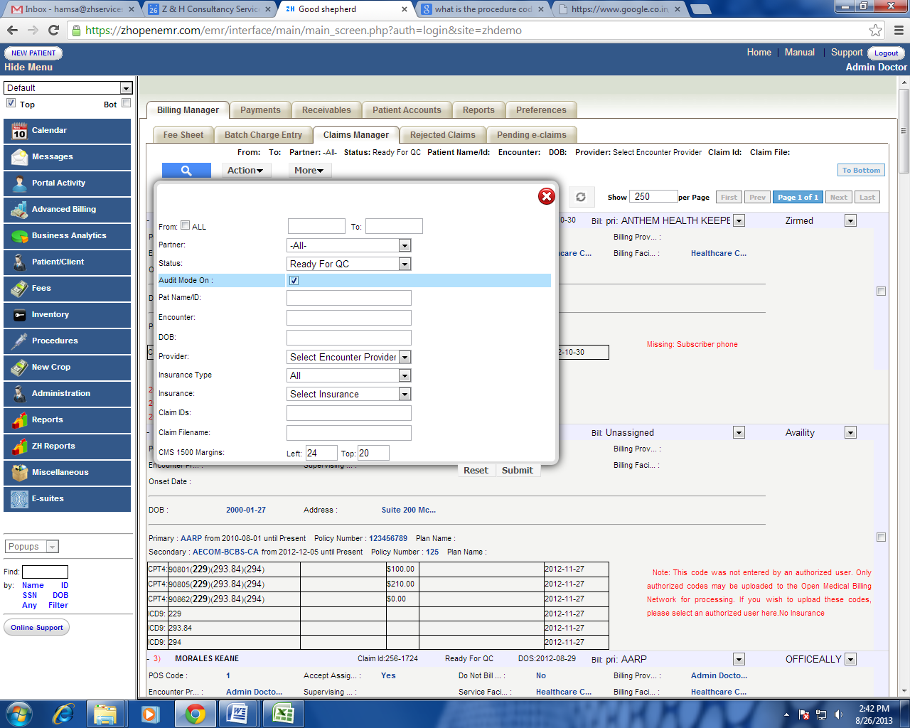

“Audit mode on” option allows the user to view the information entered in the fee sheet as shown below. Auditor can right click on any claim to view/edit all the information about the patient and the claims from the same screen is also shown below.

ZH OpenEMR has the best feature in auditing the claims and escalating it for correction , Authorize Failed is the option to identify claims which requires additional information or information missing or information not entered.

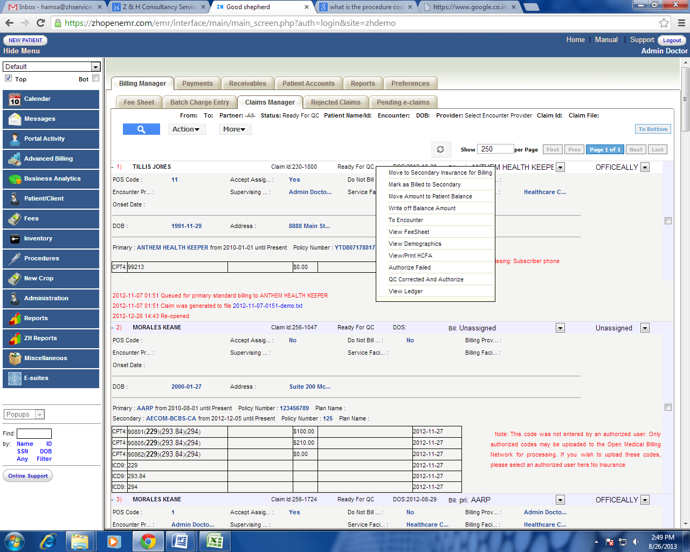

Ready to te Billed Claims which are authorized by the auditor can be generated in this screen.This status can be used to submit all claims at one go from this screen.

The user can select the X12 partner before submitting claims from claims manager screen as shown

below,

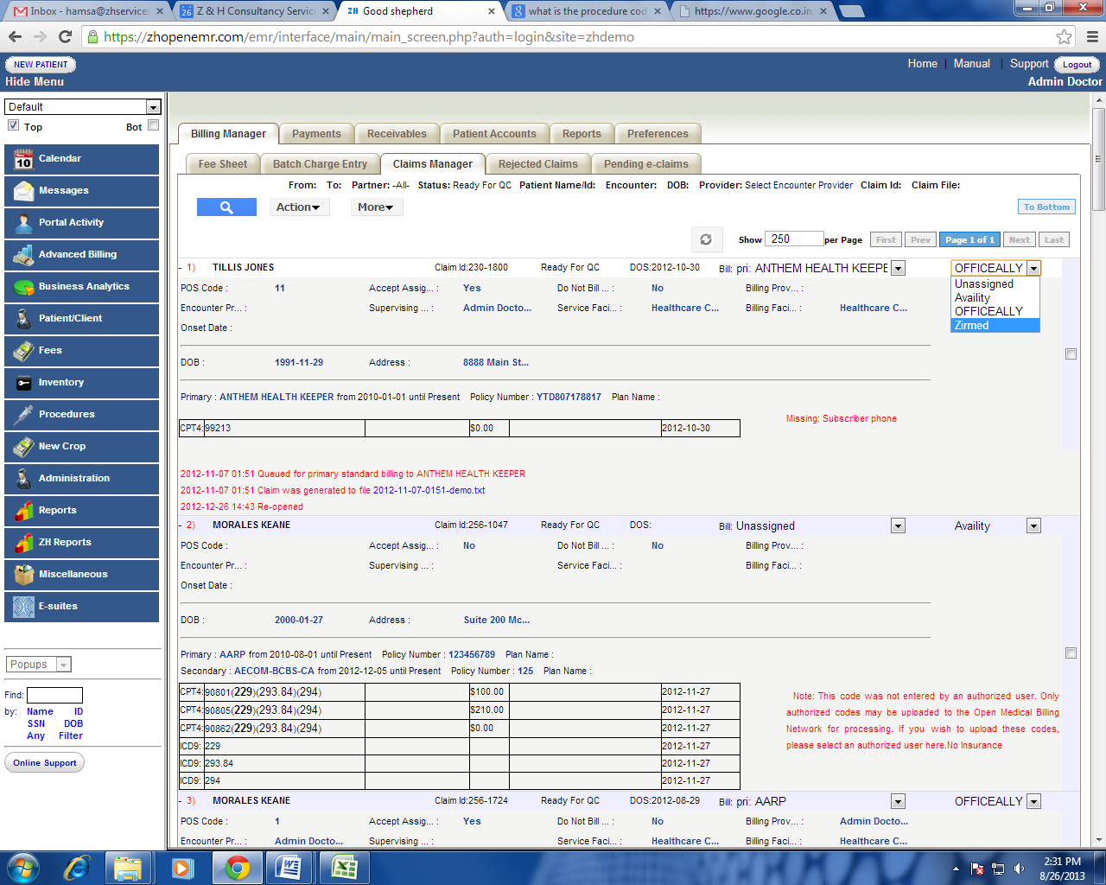

Billed You can view the claims that are being billed (submitted to Insurance) by the user. User can also edit or view the claim information even after the claim was billed.

Denied Claims that are denied by the payers. User can re-work on the denied claims and can re-submit from this screen.

Paid Claims which are paid and posted in the system..

Patient balance Accounts with patient balance in the system can be generated in this screen for any correction required.

Authorize Failed User can generate claims which are marked as Authorize Failed by auditor to do necessary correction.

Once the required information been entered. User can make the claims as QC corrected and

authorize, this action will allow the system to que the claim into ready to be billed status.



Capitation Claims which are paid by capitation fee agreement can be genrated in this screen for verification.